Abstract— Email communication has become an essential medium for information exchange; however, it is increasingly threatened by spam and phishing attacks. These malicious emails not only reduce productivity but also pose serious security risks such as identity theft and financial fraud. This paper presents a machine learning-based framework for efficient email spam detection using multiple classification models. The proposed system follows a structured pipeline that includes data preprocessing, feature extraction using TF-IDF, model training, and classification. Four models, namely Support Vector Machine (SVM), Random Forest (RF), Linear Support Vector Classifier (Linear SVC), and a Hybrid Linear SVC with calibration, are implemented and evaluated. Experimental results demonstrate that all models achieve high accuracy, with the hybrid model outperforming others. Specifically, the Hybrid Linear SVC achieved an accuracy of 98.27%, followed by Linear SVC (97.81%), SVM (96.89%), and Random Forest (96.56%). Performance evaluation is conducted using metrics such as precision, recall, F1-score, and confusion matrix analysis. The results indicate that the hybrid approach significantly reduces false positives and false negatives, making it more reliable for real-world applications. The findings highlight the effectiveness of machine learning techniques in detecting spam emails and emphasize the importance of model optimization and dataset size in improving classification performance. The proposed system can be integrated into email filtering systems to enhance security and user experience.
A Machine Learning Approach for Email Spam Detection and Classification
Yash Talaviya, Tirth Bhut, Pratham Gajra, and Prof. Yogeshwar Prajapati
Department of Computer Engineering, Marwadi University, Rajkot, Gujarat, India

INTRODUCTION
Electronic mail (email) has become one of the most essential modes of communication in modern society. However, the widespread use of email systems has also led to a dramatic increase in spam messages. Spam emails are unsolicited messages typically sent in bulk and often contain advertisements, fraudulent schemes, or malicious content. According to recent studies, a significant percentage of global email traffic consists of spam, making effective filtering mechanisms crucial.
Traditional spam filtering techniques rely on rule-based or keyword-based approaches, which are limited in their ability to adapt to new and evolving spam patterns. Attackers continuously modify email content to bypass these filters, resulting in reduced detection accuracy and increased vulnerability.
Machine learning (ML) techniques offer a promising alternative by enabling systems to learn patterns from historical data and generalize to unseen instances. ML-based spam detection systems can dynamically adapt to new spam trends and provide higher classification accuracy. This paper proposes a comprehensive ML-based spam detection framework that integrates preprocessing, feature extraction, and multiple classification algorithms.
The main contributions of this work are as follows:
- Development of a robust spam detection pipeline using TF-IDF feature representation.
- Implementation and comparison of multiple machine learning models.
- Performance evaluation using standard classification metrics.

Related Work
Email spam detection has been extensively studied in the field of text classification. Early approaches relied on heuristic and rule-based filtering techniques, which lacked adaptability and scalability.
Naive Bayes classifiers have been widely adopted due to their simplicity and efficiency in handling high-dimensional text data. These probabilistic models assume feature independence and perform well in many spam detection tasks. However, their performance may degrade when dealing with complex feature dependencies.
Support Vector Machines (SVM) have demonstrated superior performance in text classification problems due to their ability to handle high-dimensional feature spaces. SVM models aim to find an optimal hyperplane that separates spam and non-spam emails with maximum margin.
Ensemble methods, such as Random Forest, combine multiple decision trees to improve classification accuracy and reduce overfitting. These methods have shown promising results in spam detection tasks by capturing complex relationships within the data.
Despite these advancements, existing systems face challenges such as data imbalance, feature sparsity, and lack of adaptability to zero-day spam attacks. Therefore, there is a need for more robust and scalable approaches
Feature extraction techniques play a critical role in spam detection systems. Methods such as TF-IDF and Bag-of-Words are widely used due to their efficiency and effectiveness. Lightweight models like Multinomial Naive Bayes combined with Count Vectorizer offer a balance between computational efficiency and classification accuracy, making them suitable for real-time applications

TABLE I Literature Review

Ref. | Methodology | Key Findings | Accuracy | Dataset | Limitations | How to Overcome Limitations
[1] | SMART Framework: Combines Word2Vec, K-means clustering, BERT for semantic enhancement, Multi-objective adversarial training, and Reinforcement Learning (RL). | Traditional static rules struggle with evolving spam. RL and adversarial training allow the model to adapt dynamically to new spammer tactics. | Accuracy: >92%. | References standard datasets like Enron in related work, though specific experimental dataset is not explicitly detailed in snippet. | Traditional methods fail against sophisticated adversarial attacks and lack adaptability. | Proposed Solution: Use reinforcement learning to update detection policies dynamically and adversarial training to robustify against attacks.
[2] | OOAD Methodology: Supervised ML algorithms (Naive Bayes, SVM, Random Forest) with NLP techniques like TF-IDF. | SVM and Random Forest are highly effective. OOAD provides a modular, scalable design. | Accuracy: >94%. | Labeled dataset of 5,572 messages (4,825 Ham, 747 Spam) (Matches SMS Spam Collection stats). | Rule-based approaches are easily evaded. System scalability and maintainability are often overlooked. | Proposed Solution: Integrate Object-Oriented Analysis and Design (OOAD) for modularity and use robust ML models for better accuracy.
[3] | LLM-based: Uses GPT-4 with prompt engineering (Chain-of-thought). Includes email parsing, decoding, and simplification to fit token limits. | LLMs provide detailed reasoning for classifications, increasing user trust. GPT-4 outperforms Llama 2 and PaLM 2. | Accuracy: 93.70% (GPT-4). | Custom Dataset: Collected recent phishing and legitimate emails (as public datasets like Enron are outdated). | LLM token limits restrict input size. Public datasets are outdated. Black-box models lack explainability. | Proposed Solution: HTML/text simplification to manage tokens. Generate detailed rationales for users.
[4] | Hybrid ML: Count Vectorizer (Bag-of-Words) with Multinomial Naive Bayes. Preprocessing includes stopword removal and stemming. | Lightweight models like Naive Bayes are scalable and effective for real-time deployment. | Strong performance in precision, recall, and accuracy (exact % not in snippet). | SMS Spam Collection Dataset (UCI): 5,572 messages (4,825 Ham, 747 Spam). | High false positives in traditional filters. Computational efficiency vs. accuracy trade-off. | Proposed Solution: Use lightweight vectorization (Count Vectorizer) and Naive Bayes for a balance of speed and accuracy.
[5] | Point-Biserial Correlation for feature selection. Algorithms: SVM, ANN, KNN, RF, DT, Logistic Regression. | Feature selection is critical. SVM and ANN outperformed other classifiers. | SVM Accuracy: 91.00%; ANN Accuracy: 92.06%. | UCI Spambase Dataset (approx. 5,000 instances). | Overfitting in complex models (like ANN) with small datasets. Previous studies often lacked rigorous feature selection. | Proposed Solution: Apply Point-Biserial feature selection to reduce dimensionality and use 10-fold cross-validation.
[6] | Review Study: Analyzes ML, Deep Learning (CNN, LSTM, BERT), and Fuzzy Systems. | DL methods are superior but resource-intensive. Hybrid models (e.g., Fuzzy-SVM) show promise. | Cites SVM at ~91% and DL models >92%. | Reviews various datasets including CSDMC2010, Enron, SpamAssassin. | Data imbalance, concept drift (evolving spam), and lack of interpretability in Deep Learning models. | Proposed Solution: Adversarial training , Explainable AI (XAI) , and Hybrid systems.
[7] | Supervised Learning: Review of Naive Bayes, SVM, RF, NN. Proposed Hybrid Framework (Heuristic + ML). | ML adapts to patterns that static rules miss. Feature engineering is key. | SVM Accuracy: 92.10%; | Mentions SpamAssassin, Enron, Ling-Spam. | Adversarial spam (obfuscation), Data Imbalance, Real-world deployment challenges. | Proposed Solution: Continuous retraining, SMOTE for imbalance, and a hybrid framework with feedback loops.
[8] | Comparative Analysis: SVM, Decision Tree, Naive Bayes using TF-IDF and Bag-of-Words. | SVM is the most effective for complex datasets. Naive Bayes and DT are satisfactory but less robust. | SVM Accuracy: 91.48%. | Kaggle Dataset (matches SMS Spam Collection): 5,572 messages (4,825 Ham, 747 Spam). | Overfitting, scalability issues, and maintenance of models. | Proposed Solution: Combine advanced feature extraction with customized SVM kernels.
[9] | Web Integration: RF, KNN, ANN optimized with GridSearchCV. Integrated into a Django Web App. | Random Forest (RF) achieved the highest accuracy. Real-time integration is feasible. | RF Accuracy: 92.78%; KNN: 93.67%; | Datasets from Ariyadasa et al. (2021) and UNB (2016). | Previous studies lacked end-user integration. KNN is computationally intensive during testing. | Proposed Solution: Deploy the optimal model (RF) via a user-friendly Django web interface for real-time detection.
[10] | Evaluated five ML classifiers (NB, LR, SVM, DT, RF) with feature standardization. Used SHAP for model interpretability. | Random Forest was the best-performing model. SHAP analysis confirmed classification relies on meaningful attributes | Random Forest: 94.57%, SVM: 93.38%, LR: 92.4%. | UCI Spambase dataset (4,601 email instances). | Traditional ML struggles with dynamic modern spam. The study is limited to a single dataset. | Explore hybrid models or deep learning approaches on more diverse, continuously evolving datasets.
[11] | Evaluated NB, LR, Extra Tree, SGD, XGBoost, SVM, RF, and MLP with Count-Vectorizer and TFIDF. Used Grid, Random, and Genetic algorithms (TPOT) for hyperparameter tuning. | Stochastic Gradient Descent (SGD) consistently outperformed other algorithms. Hyperparameter tuning and feature selection significantly enhanced | SGD: 96.83% (Ling-Spam), 95.12% (UCI), 94.08% (Custom). Extra Trees average: 95.93%. | Ling Spam, UCI SMS Spam, and a new Custom Dataset featuring a 25% spam rate. | The method relies purely on text-based attributes and may miss advanced evasion techniques like steganography. | Employ image processing specifically to tackle stenographic emails and leverage deep neural network architectures for complex features.

Proposed Methodology
The proposed methodology consists of several stages, forming a complete spam detection pipeline.
A. Data Collection
A labeled dataset containing spam and ham emails is utilized. Publicly available datasets such as Enron or SpamAssassin can be used for experimentation.

B. Data Preprocessing
Raw email data is preprocessed to remove noise and improve data quality. This includes:
- Conversion to lowercase
- Removal of punctuation and special characters
- Stopword removal
- Tokenization

C. Feature Extraction
Textual data is transformed into numerical vectors using the TF-IDF technique. TF-IDF assigns weights to words based on their frequency and importance, enabling effective representation of email content.
Mathematically, TF-IDF is defined as:
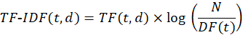
where is the term frequency, is the document frequency, and is the total number of documents.

D. Classification Models
Multiple machine learning models are implemented to classify emails as spam or ham. These include Naive Bayes, Support Vector Machine (SVM), Random Forest, and Linear Support Vector Classifier (Linear SVC). Additionally, a hybrid Linear SVC model with calibration is used to improve classification accuracy. These models are selected due to their effectiveness in handling high-dimensional text data.

E. Training and Testing
The dataset is divided into training and testing subsets using an 80:20 ratio. The models are trained on the training dataset and evaluated on the testing dataset. Performance is measured using metrics such as accuracy, precision, recall, and F1-score.

F. System Workflow
The overall workflow of the proposed system is illustrated in Fig. 1. The process begins with loading the email dataset, followed by data cleaning and preprocessing. The processed data is then split into training and testing sets. Machine learning models are trained using the training data and used to make predictions on unseen data.
The system then performs a decision-making step to determine whether an email is phishing (spam) or safe (ham). Based on the classification result, the corresponding message is displayed to the user. This structured workflow ensures an efficient and automated spam detection process.

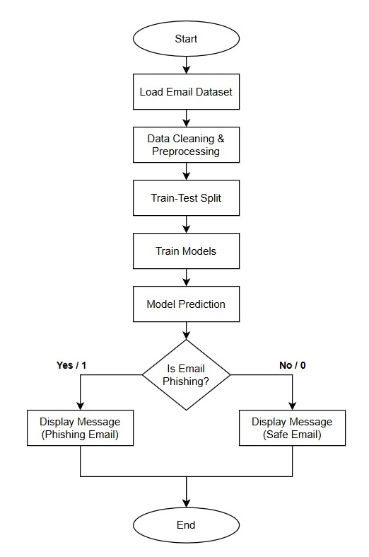
Fig. 1 System Workflow(Flow Chart)

Experimental Setup
The experiments are conducted using Python with libraries such as Scikit-learn, Pandas, and NumPy. The implementation environment includes:
- Processor: Intel Core i5 or higher
- RAM: 8 GB
- Operating System: Windows/Linux

Evaluation metrics used include:
- Accuracy
- Precision
- Recall
- F1-score
These metrics provide a comprehensive understanding of model performance.

Result and Discussion
The performance of the proposed spam detection system is evaluated using multiple machine learning models, including Support Vector Machine (SVM), Random Forest (RF), Linear Support Vector Classifier (Linear SVC), and a Hybrid Linear SVC model with calibration. The evaluation is conducted using standard performance metrics such as accuracy, precision, recall, F1-score, and confusion matrix.
A. Performance of Individual Models
The SVM model achieved an accuracy of 96.89%, demonstrating strong classification performance with balanced precision and recall. The confusion matrix shows that the model correctly classified most spam and ham emails, with minimal misclassification.
Similarly, the Random Forest model achieved an accuracy of 96.56%, slightly lower than SVM. While RF performed well in identifying safe emails, it showed a slightly higher number of false negatives compared to SVM
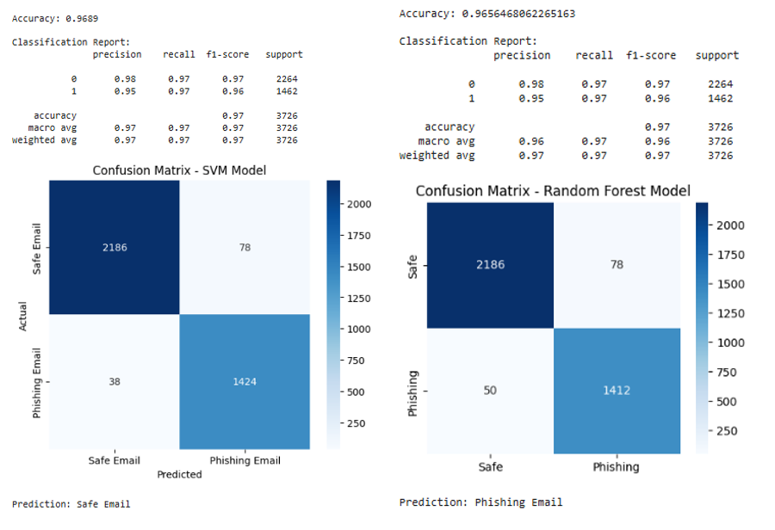
Fig. 2. Confusion matrices and classification for SVM and RF models

B. Performance of Advanced Models
The Linear SVC model demonstrated improved performance with an accuracy of 97.81%, benefiting from efficient handling of high-dimensional textual data. Furthermore, the Hybrid Linear SVC model, combined with calibration techniques, achieved the highest accuracy of 98.27%.
The hybrid model making it more reliable for real-world deployment. The confusion matrix shows improved classification in both spam and ham categories.
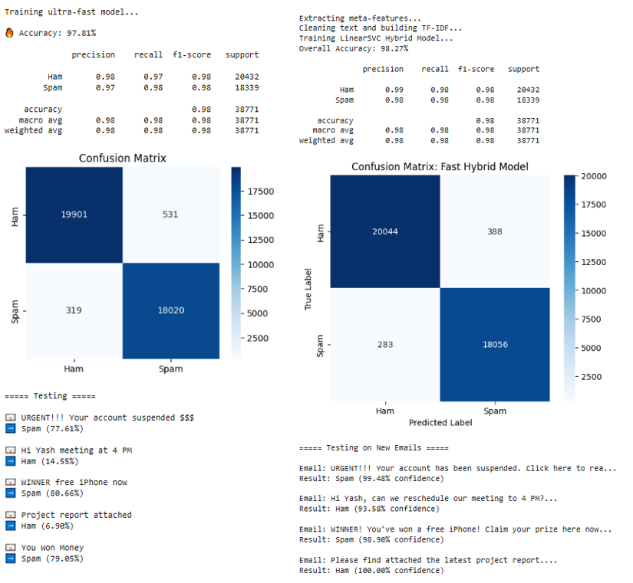
Fig. 3. Confusion matrices and performance evaluation of Linear SVC and Hybrid models

C. Comparative Analysis
To provide a comprehensive comparison, all models are evaluated based on dataset size, accuracy, and error rates. The results are summarized in Table II.

TABLE II COMPARISON OF MODEL PERFORMANCE
Model Architecture | Dataset Size | Overall Accuracy |  | False Positives (FP) | False Negatives (FN)
Linear SVC | Large | 97.81% |  | 531 | 319
Linear SVC + CalibratedClassifierCV | Large | 98.27% |  | 388 | 283
SVM | Small | 96.89% |  | 78 | 38
Random Forest | Small | 96.56% |  | 78 | 50

D. Discussion
From Table II, it is evident that the Hybrid Linear SVC model outperforms all other models, achieving the highest accuracy of 98.27%. This improvement can be attributed to calibration, which enhances probability estimation and decision boundaries.
Although traditional models such as SVM and Random Forest perform well, they are less effective compared to advanced linear models when handling large-scale textual datasets. Additionally, the Linear SVC model provides a good trade-off between computational efficiency and classification accuracy.
Another key observation is that models trained on larger datasets tend to perform better due to improved generalization. The reduction in false positives and false negatives in the hybrid model further highlights its suitability for real-world spam detection systems.

Conclusion
This paper presented a comprehensive machine learning-based approach for email spam detection. The system incorporates data preprocessing, feature extraction, and classification using multiple models, including SVM, Random Forest, Linear SVC, and a Hybrid Linear SVC model.
The experimental results demonstrate that machine learning techniques are highly effective in identifying spam emails with high accuracy. Among the evaluated models, the Hybrid Linear SVC achieved the best performance, with an accuracy of 98.27%, along with reduced false positives and false negatives. This highlights the importance of model calibration and optimization in improving classification outcomes.
Additionally, the study shows that models trained on larger datasets tend to perform better due to improved generalization capabilities. While traditional models such as SVM and Random Forest provide reliable performance, advanced linear models offer a better balance between computational efficiency and accuracy.
Overall, the proposed system provides a robust and scalable solution for spam detection and can be effectively deployed in real-world email systems. The results validate that combining efficient feature extraction with optimized machine learning models significantly enhances spam filtering performance.

Future Work
Future research can focus on enhancing the proposed spam detection system by incorporating advanced deep learning models such as Long Short-Term Memory (LSTM) networks and transformer-based architectures for better contextual understanding of email content. The integration of real-time spam filtering systems can further improve practical applicability in dynamic environments. Additionally, extending the system to support multilingual datasets will enable detection of spam emails across different languages.
Another important direction is addressing sophisticated spam techniques such as image-based spam, steganography, and adversarial attacks by combining text and image processing methods. The use of Explainable Artificial Intelligence (XAI) can improve transparency and user trust by providing clear justifications for classification decisions. Furthermore, implementing online learning or incremental training strategies can help the model adapt to evolving spam patterns over time.
These improvements will make the system more robust, scalable, and suitable for deployment in real-world email filtering applications.
References
- Taha, Kamal. "Smart: semantic, multi-objective, and reinforcement-based adversarial training for email spam detection." IEEE Access (2025).
- I. G. Akawuku, S. O. Adejumo, S. M. Alade, A. A. Olatunde, David, and B. Mulumeoderhwa, "Development of an Efficient Machine learning-based Email spam Detection System," Newport International Journal of Engineering and Physical Sciences, vol. 5, no. 2, pp. 1-10, 2025
- Koide, Takashi, et al. "Chatspamdetector: Leveraging large language models for effective phishing email detection." International Conference on Security and Privacy in Communication Systems. Cham: Springer Nature Switzerland, 2024.
- Abhinav, Dhara, Ch Bhuvan, and M. Hemanth. "A Hybrid Approach for Email Spam Detection Using Text Vectorization and Machine Learning Models." 2025.
- Iqbal, Khalid, and Muhammad Shehrayar Khan. "Email classification analysis using machine learning techniques." Applied Computing and Informatics 21.3-4 (2025): 390-402.
- Tusher, Ekramul Haque, et al. "Email spam: A comprehensive review of optimize detection methods, challenges, and open research problems." IEEE Access 12 (2024): 143627-143657.
- Patil, Aditi, and Priyanka Singh. "Spam Detection Using Machine Learning." IJSAT-International Journal on Science and Technology 16.2 (2025).
- M. B. Sakib and S. Mistry, "Email Spam Detection Using Machine Learning: A Comparative Analysis of Classification Algorithms," American International University, Dhaka, 2026.
- Onih, V. Adeyemi. "Phishing Detection Using Machine Learning: A Model Development and Integration." International Journal of Scientific and Management Research 7.04 (2024): 27-63.
- D. Singh, "A Comparative Analysis of Classical Machine Learning Algorithms for Email Spam Detection," International Journal of Computer Techniques (IJCT), vol. 12, no. 6, Nov. 2025.
- S. M. Ngigi, J. Karani, R. Mathenge, and N. Muriithi, "Spam Detection in Emails Using Machine Learning Techniques: A Review," International Journal of Computer and Information Technology, vol. 13, no. 3, Sep. 2024.
- R. Fatima, M. M. S. Fareed, S. Ullah, G. Ahmad, and S. Mahmood, "An Optimized Approach for Detection and Classification of Spam Email's Using Ensemble Methods," Wireless Personal Communications, vol. 139, pp. 347–373, Nov. 2024.
- F. Jáñez-Martino, R. Alaiz-Rodríguez, V. González-Castro, E. Fidalgo, and E. Alegre, "Classifying spam emails using agglomerative hierarchical clustering and a topic-based approach," Information Sciences (or respective journal based on INCIBE dataset publication), 2024.
- N. Al-shanableh, M. S. Alzyoud, and E. Nashnush, "Enhancing Email Spam Detection Through Ensemble Machine Learning: A Comprehensive Evaluation of Model Integration and Performance," Communications of the IIMA / International Information Management Association (IIMA) Conference Proceedings, 2024.
- R. Sulthana A, A. Verma, and J. A. K., "A detailed analysis on spam emails and detection using Machine Learning algorithms," Department of Computing and Mathematical Sciences, University of Greenwich, 2023.
- G. Borotić, L. Granoša, J. Kovačević, and M. B. Babac, "Effective Spam Detection with Machine Learning," Croatian Regional Development Journal, vol. 4, no. 2, 2023.
- A. Felciya I, E. Devi S, M. Maheswari, and S. Roselin Mary, "Email Spam Detection Using Machine Learning Algorithms," International Journal of Advanced Research in Computer and Communication Engineering (IJARCCE), vol. 12, no. 5, May 2023.
- S. M. Yasin and I. H. Azmi, "Email Spam Filtering Technique: Challenges and Solutions," Journal of Theoretical and Applied Information Technology, vol. 101, no. 13, Jul. 2023.
- P. T. Nallamothu and M. S. Khan, "Machine Learning for SPAM Detection," Asian Journal of Advances in Research, vol. 6, no. 1, pp. 167-179, Mar. 2023.
- P. Charanarur, H. Jain, G. S. Rao, D. Samanta, S. S. Sengar, and C. T. Hewage, "Machine-Learning-Based Spam Mail Detector," SN Computer Science, vol. 4, no. 858, Aug. 2023.
- I. Moutafis, A. Andreatos, and P. Stefaneas, "Spam Email Detection Using Machine Learning Techniques," Proceedings of the 22nd European Conference on Cyber Warfare and Security (ECCWS), pp. 320-328, 2023.
- P. Mantri and R. Keole, "A Review on Spam Email Detection using Machine Learning," Journal of Emerging Technologies and Innovative Research (JETIR), vol. 9, no. 4, Apr. 2022.
- A. O. Gabriel and A. A. Joy, "An Email Spam Filtering Model Using Ensemble of Machine Learning Techniques," International Journal of Computer Applications Technology and Research, vol. 11, no. 3, pp. 66-71, 2022.
- A. Shirwadkar and S. Jacob, "Spam Mail Classifier," International Journal for Research in Applied Science & Engineering Technology (IJRASET), vol. 10, no. 12, Dec. 2022.
- C. Abhinav, K. Jayachandra, K. P. Kumar, and V. Sowmya, "Spam Mail Detection using Machine Learning," International Journal for Research in Applied Science & Engineering Technology (IJRASET), vol. 10, no. 6, Jun. 2022.



 

